**CREATE AN ACCOUNT IN CLARIFAI**

|  |  |
| --- | --- |
| **DATE** | **29 OCTOBER 2022** |
| **TEAM ID** | PNT2022TMID24852 |
| **PROJECT** | IOT BASED CROP PROTECTION SYSTEM |

To detect the animals and birds we are using an open-source platform Clarifai. To use this service in the project we need to sign up for this.

**CLARIFAI**

Clarifai provides an end-to-end platform with the easiest to use UI and API in the market. Clarifai Inc. is an artificial intelligence (AI) company that specializes in computer vision and uses machine learning and deep neural networks to identify and analyse images and videos. The company offers its solution via API, mobile SDK, and on-premise solutions.

**STEP 1:**

• Open Clarifai portal in web browser

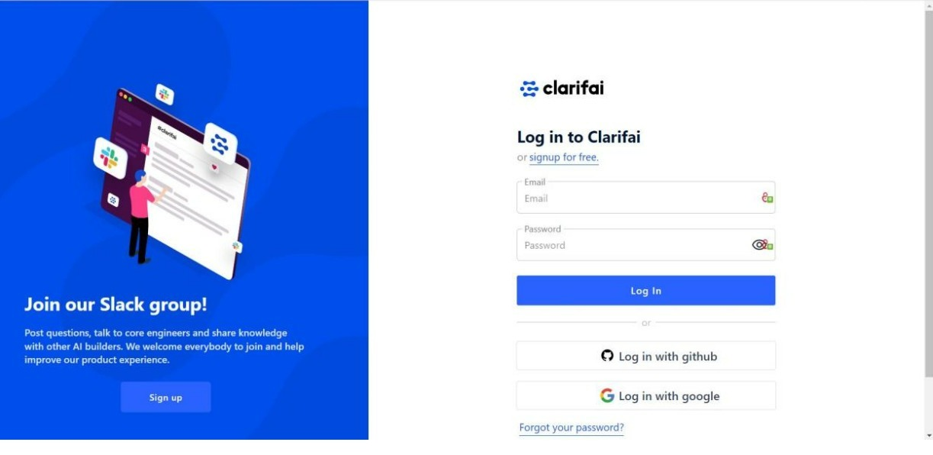

**STEP 2:**

• Signup using the required user mail and password.

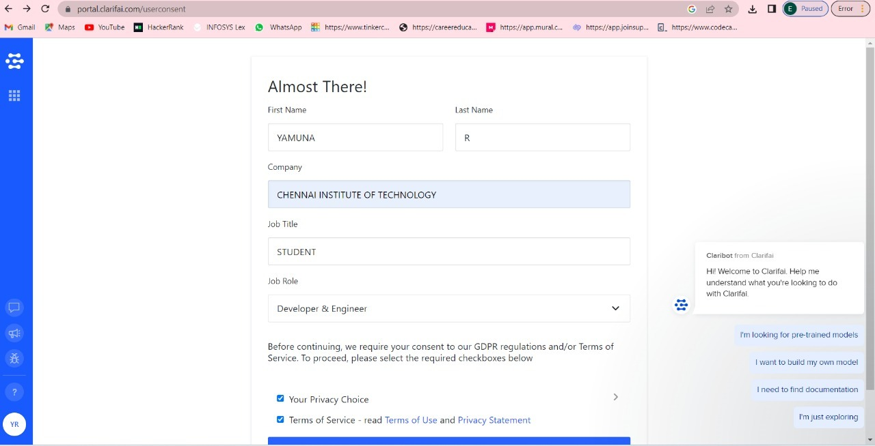

**STEP 3:**

•Finally, Created an account.

